Control Systems Lab

Lab 6 Speed Control of a DC Motor

Objectives
- Compare predicted and experimental response of proportional, pure integral, and PI (proportional plus integral) compensation for speed control of a DC motor
- Discuss performance of the real control system versus the ideal expected behavior

Overview
In this lab you will evaluate the compensators designed in the prelab by comparing the experimental data with the predicted response.

Experiment vs. Theory
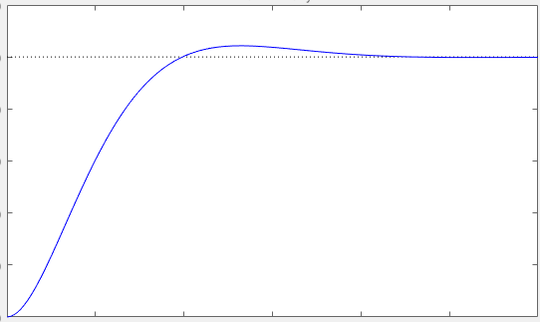
You will be providing 3 graphs total. In the graphs below you will want to plot a response similar to what you would predict from SISOtool, including the reference signal and the actual response. Zoom in enough to capture the transient and the steady state response. All figures need proper labels, units, title and a legend for all the curves plotted.

Part 1: Proportional Control

- On the same graph plot:
  - The experimental response with proportional speed control using $K_{pmax}$ determined in prelab with the 0.5 volts offset added for reference of 155 rad/sec
  - The reference signal
  - The theoretical response based on the closed loop transfer function using the ideal DC motor model. (use MATLAB and the step command as in lab 5):

GCL = C*G/(1+C*G*1); % GCL
[y,t]=step(R*GCL); % R is reference step size

- Why is 0.5 volts added to the system?

Part 2: Addressing steady-state error with a pure integrator

- On the same graph plot:
  - The experimental response with pure integral speed control using $K_{2}$ determined for $ζ=0.591$, and with the 0.5 volts offset added for reference of 155 rad/sec.
  - The reference signal.
  - The theoretical response based on the closed loop transfer function using the ideal DC motor model.

- Compared to the Part 1 proportional controller how did steady state error change?

Compared to the Part 1 proportional controller how has the settling time changed?

How well does the experiment match the theory?

Part 3: Addressing transient response with a zero

- On the same graph plot:
  - The experimental response with integral compensator with a zero for speed control using gain, $K_{3}$, and zero, $z_{c}$, determined for a $ζ=0.591$ and the settling time improved by a factor of two, and with the 0.5 volts offset added for reference of 155 rad/sec.
  - The reference signal.
  - The theoretical response based on the closed loop transfer function using the ideal DC motor model.
  - The theoretical response based on the closed loop transfer function using the ideal DC motor model but add in a delay based off the microprocessor delay of 0.004 seconds using the following sample code:

d=tf(1,1,'InputDelay',.004) % delay
CLTF=feedback(d*C*G,1) % CLTF with delay
[y,t]=step(155*CLTF);

- How well does the theory match the experiment? Comment on the effect of the microprocessor delay.

The compensator is a pole at the origin to address steady state error with a zero to adjust transient response. Show below that a “PI” compensator (proportional PLUS integral) has a pole at the origin and a zero:

